**Features implemented**

Our application is able to record time, x_vel, y_vel, Z_vel, pitch, roll, yaw , altitude. Our application only works on Windows, and has an .exe for ease of access. With every flight, the application will make a new data file.

**Remains to be done**

Our team was not able to port the application to mobile. Our final project was meant to be on IOS, but we fell short. After porting the application to mobile, the next step would be the usage of the camera.

**Known Issues**

Our application crashes when working on a MAC. Which made it hard for us to deploy the application on an IOS. Many guides on the net, told us that we needed an MAC if we were to deploy on an IOS. When on MAC, the land button would crash the application, leaving the drone to fly without any input. Since the device needed to be connected to the WI-fi of the drone, we could not figure out how to send the data to the student, without disconnecting from the drone. The drone had an emergency status, that we could not work around. Once it crashes, we had to restart the application and the drone. Our choice of framework, caused us the short coming. We thought that QTPy was the correct framework, but it produced more problems for us.

**Meet the Team: Game Of Drone**

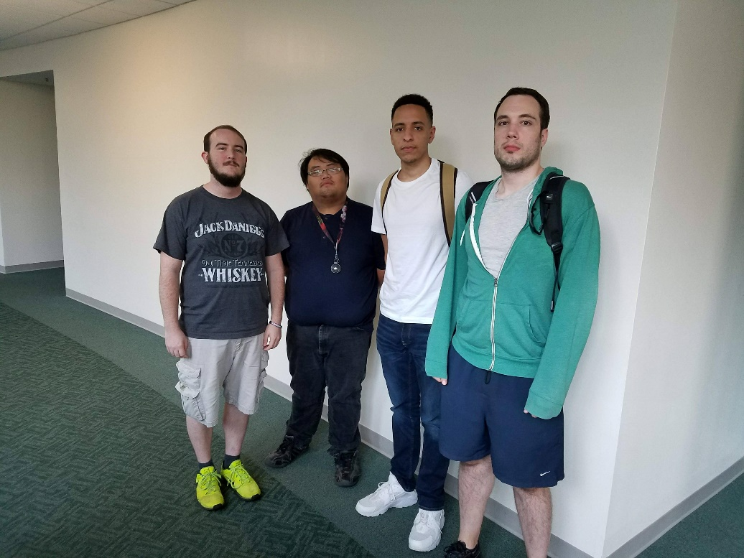

**Role:** Team Leader/Client Liaison/Ui/Ux Design

Name: Gabriel Mezuita



**Bio:**

Programming: Intro(Python), Fundamentals, Intermediate, Advanced

Software Development I

Intro to Databases

Web Technologies

Computer Graphics and Multimedia

Currently in: System Analysis and Design, Software QA, Game Development, Mobile Apps

Skills:

Problem Solving and Planning

Java, some python, MySQL

Interests:

Video games, programming, creating

Soft, dev tools:

Eclipse, some Git/Github

Software Projects:

Text based game in Soft. Dev I

**Role:** Code Architecture / Lead Programmer

**Name:** Tony Neese



**Bio:**

Concentration/year: 3rd Year IT(Software Development)

Previous courses: Intermediate/ Advanced Programming, Python, Intro to Database, System Analysis & Design

Skills: Python/Java

Interests: Web Design, Mobile Application Development

Expertise in software development tools: Very little

Past software projects: Team project that created a text-based adventure game

**Role:** Data Modeler

**Name:** Steven Beteag



**Bio:**

Software Dev / Senior

Python, Java, SQL (MySQL, MongoDB, Postgresql, sqlite), HTML, CSS, some jquery and javascript

Pycharm, intelliJ

Back end, web dev

Past project: A website to pick the classes you need and it shows all working

**Role:** Documentation Lead

**Name:** Matthew Xiong

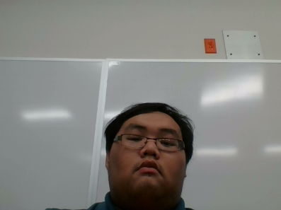

Bio: Software Development Junior

Software Devel I, Intro to Database,Adv programming, System Analysis

Java and Eclipse

Worked on a text based game named Zombie Hospital, I help design the rooms and levels for the game

Expertise in software development tools (IDEs, version control, build tools, etc):Little

Interest: Developing games

**Role:** Customer

**Name:** Matthew Stackpole



**Bio:**

Doctorate – mathematics – University of Colorado at Boulder

Bachelor's – mathematics and physics – Lawrence University

Even though he is a Professor of Mathematics, Professor Stackpole showed interest in Information Technology. Because of this, grant money was given to Professor Stackpole and his team to buy Quadcopters to give calculus students an opportunity to collect and model real data.

In his free time, he loves to practice coding and loves to play video games.

**Role:** Customer

**Name:** Keith Erickson



**Bio:**

Doctorate – bioengineering – University of California, Berkeley/San Francisco

Bachelor's – chemical engineering – University of Washington

“He was awarded a Davies Fellowship in the Department of Mathematical Sciences at the United States Military Academy at West Point. This award gave him the opportunity to teach mathematics to future Army officers.”

He has two Cats

**Link to our Survey:**

<https://docs.google.com/spreadsheets/d/1ymTqj2tG2GacEnrnUUFcl0xEBjyEqWa4GZYGixfWW5M/edit#gid=1861669508>

**Where to get the files:**

<https://github.com/soft-eng-practicum/GameOfDrones>

To use the application, just clone the repo.

Once cloned, open of the “Dist” folder and inside will be a main.exe file.

Run main.exe and it will work. (Only on Windows)

Does not need, Python to run.

In the same folder. The Flight data will be saved as (.csv) file.

**Testing**

The drone’s movement functions are automatically tested as the code changes.

Testing for the UI and data saving would come in later updates.

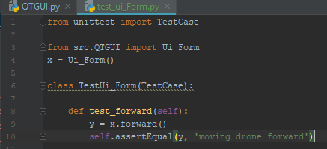

**Our Demo:**

<https://youtu.be/KFycTiE1j-c>

**Functionality:**

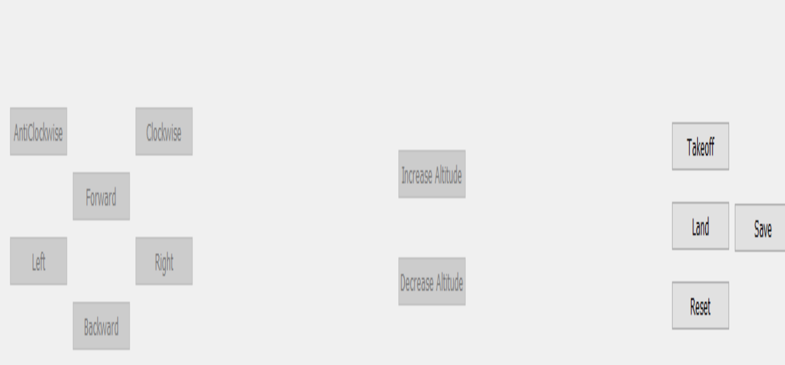

**Instruction:**

**Take Off:** Lifts the Drone into the air, and puts in hover mode ( Link to: “T” on keyboard)

**Land:** Carefully lands the drone back on the ground. (Link to: “L” on keyboard)

**Reset:** Resets the emergency mode (Link to: ”P” on keyboard)

**Save:** Saves the flight data in a (.cvs) file

**Increase Altitude:** Slowly increase the Altitude (up) (Link to: “Space” on keyboard)

**Decrease Altitude:** Slowly decreases the Altitude (down) (Link to: “C” on keyboard)

**Clockwise:** Rotates to the right (Link to: “E” on keyboard)

**Anti-Clockwise :** Rotates to the left (Link to: “Q” on keyboard)

**Forward:** Moves forward (Link to: “W” on keyboard)

**Backward:** Moves backwards (Link to: “S” on keyboard)

**Left:** Moves left (Link to: “A” on keyboard)

**Right:** Moves right (Link to: “D” on keyboard)

(Note: Pay attention to the lights on the wings, the two green lights in the front represents the front of the drone.)

